Project Design Phase
Solution Architecture
Date | 27/09/2026
Team ID | SWTID-2026-8900
Project Name | Streamlining IT Procurement – Automating Standard Laptop Orders with Flow Designer

Solution architecture describes how the proposed system connects the user, IT service platform, approval process, procurement team, and automation workflow to solve the problem of manual laptop ordering.
Goals of the Solution Architecture
- Automate the standard laptop procurement process.
- Reduce manual activities and processing time.
- Provide an organized approval mechanism.
- Automatically notify employees and IT teams about request updates.
- Improve visibility and tracking of laptop requests.
- Standardize the procurement workflow.
- Make the solution scalable for other IT assets and services.
Solution Architecture Diagram
You can use the following architecture for your project:
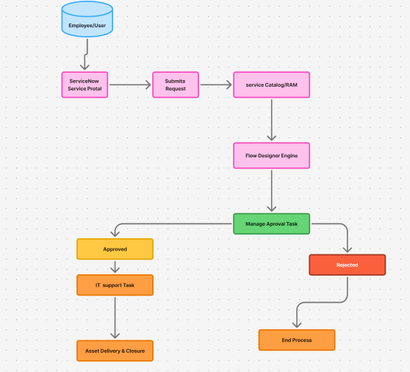
Figure 1: Solution Architecture and Data Flow for Automated Standard Laptop Procurement
Reference link: https://www.figma.com/board/XJlDhCFk76zDXd4jy0sn34/Untitled?node-id=0-1&t=3teSFRaakQZZuDub-1
Architecture Components
Component | Purpose
Employee | Submits a request for a standard laptop.
ServiceNow / IT Request Portal | Provides the interface for submitting and tracking laptop requests.
Flow Designer | Automates the workflow and connects different stages of the procurement process.
Request Validation | Checks whether the submitted request contains the required information.
Manager Approval | Provides authorization before the laptop order is processed.
IT / Procurement Team | Processes the approved laptop request and manages fulfilment.
Request/Asset Records | Stores request details and status information.
Notification System | Automatically informs employees and relevant teams about approvals, rejection, and order progress.
Laptop Fulfilment | Represents the final stage where the approved laptop is prepared and delivered to the employee.

Data Flow
The architecture follows a simple automated flow:
Employee → ServiceNow Portal → Service Catalog → Flow Designer → Approval → IT Support → Asset Delivery → Request Closure
This architecture reduces dependency on manual emails and repeated communication. Flow Designer acts as the central automation layer, coordinating the different stages of the standard laptop procurement process.

Expected Benefits
The proposed architecture provides:
- Faster laptop request processing
- Automated approval routing
- Reduced manual intervention
- Improved request tracking
- Automatic notifications
- Fewer human errors
- Standardized procurement procedures
- Better employee experience
- Easier expansion to other IT asset requests
Reference: The architecture can be presented in the same style as the AWS architecture example provided in your template, while the components and data flow are customized specifically for your Flow Designer-based laptop procurement project.

